NCMSEP File Upload Instructions

* Access the form by going to the following URL:
  + <https://lenoircc.edu/ncmsepupload>
* Fill out the form (all fields are required)

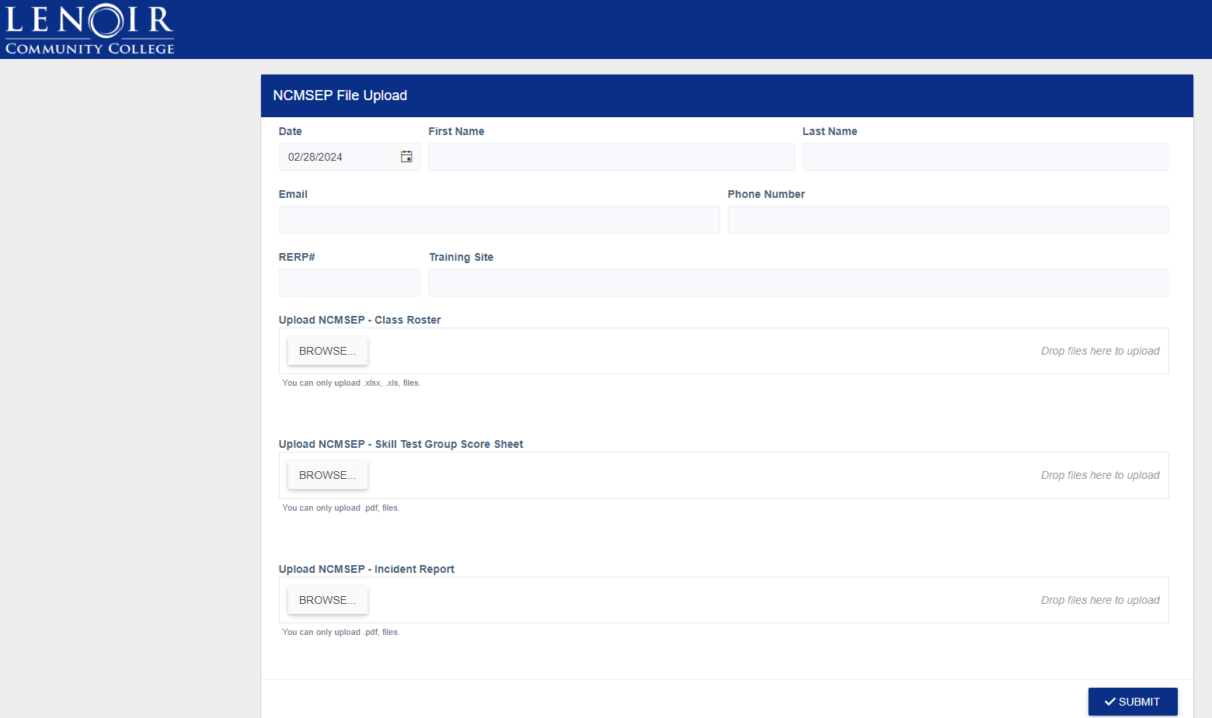

* You can upload multiple documents in each upload field if you need to:

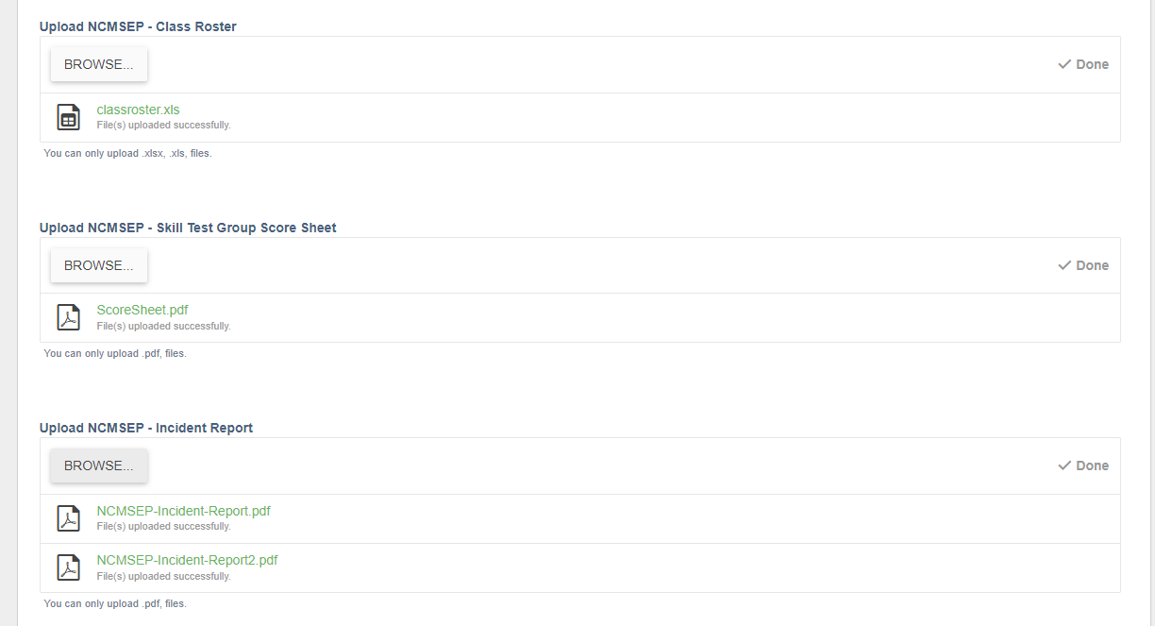

* Once you are done filling out the form and uploading the pertinent documents, click the submit button.
* You should see a confirmation message; you may now close your browser

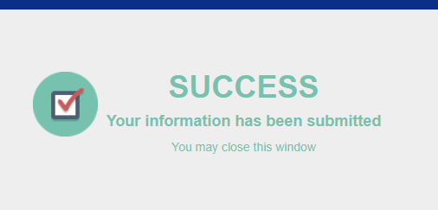

* An email will be sent to NC Motorcycle Safety Education Program at Lenoir Community College.